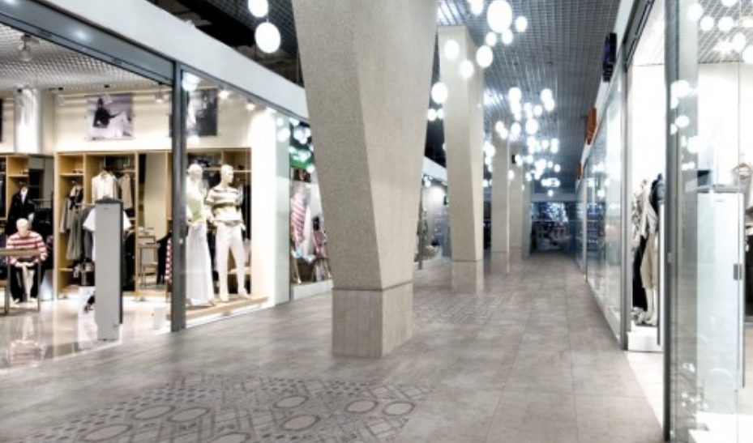

**OUTDOOR**

Our outdoor wall tiles selection includes glazed porcelains from the US manufacturer, Adeline. Italian arabescato and arancetto

marbles now available in Polished finishes.

Available in a wide variety of sizes, shapes, and mosaics.

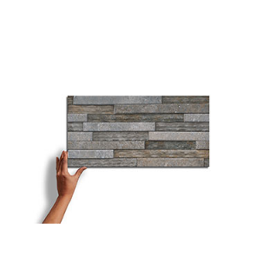

**Abstarct clien**

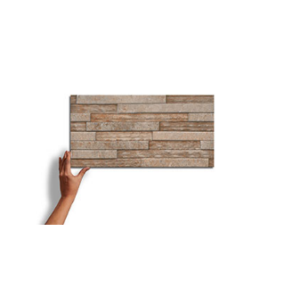

**Rial mist**

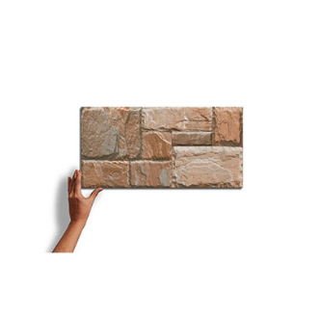

**Covretto**

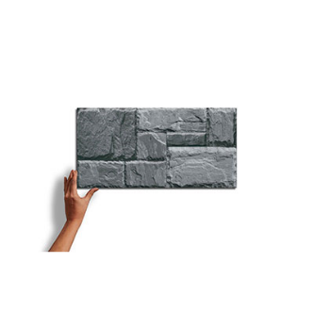

**Baroque floral dark**

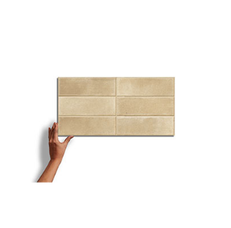

**Nuria gris**

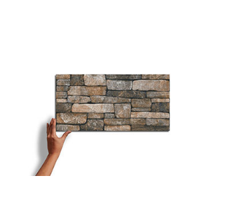

**Bayt nero**

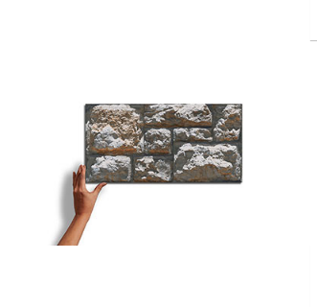

**Sandstone tusk**

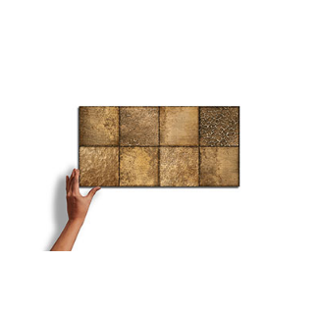

**Orfeo choco**

**OUTDOOR WALL TILES**  TECHNICAL INFORMATION

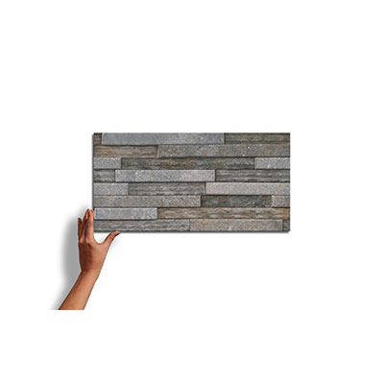

**ABSTARCT CLIEN**

A beautifully glazed porcelain collection from Italy creates a blend of marbles with a subtle antiqued look. Blending the veining of white Italian marbles (Carrara, Statuario, Gioia, and Venatino) in both White and Black creates a variety of sizes and patterns to create custom designs.

SPECIFICATIONS

**Country of Origin**

Italy

**Wear Rating**

Class 5 Suitable for all Residential and Commercial Application. Class 5 tiles are suitable for all applications including those with heavy traffic and constant use. (i.e., Shopping Malls, Hospitals), Class 3 Residential Applications. Suitable for all residential applications.

**Shade Variation**

V3 - Moderate Variation While the colors present on a single piece of tile will be indicative of the colors to be expected on the other tiles, the amount of colors on each piece will vary significantly.

**Frost Proof**

Yes

**Finish**

Glazed

**Material**

Porcelain

**Bullnose**

Yes

**OUTDOOR WALL TILES**  TECHNICAL INFORMATION

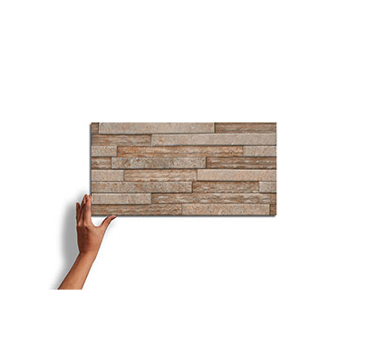

**RIAL MIST**

A beautifully glazed porcelain collection from Italy creates a blend of marbles with a subtle antiqued look. Blending the veining of white Italian marbles (Carrara, Statuario, Gioia, and Venatino) in both White and Black creates a variety of sizes and patterns to create custom designs.

SPECIFICATIONS

**Country of Origin**

Italy

**Wear Rating**

Class 5 Suitable for all Residential and Commercial Application. Class 5 tiles are suitable for all applications including those with heavy traffic and constant use. (i.e., Shopping Malls, Hospitals), Class 3 Residential Applications. Suitable for all residential applications.

**Shade Variation**

V3 - Moderate Variation While the colors present on a single piece of tile will be indicative of the colors to be expected on the other tiles, the amount of colors on each piece will vary significantly.

**Frost Proof**

Yes

**Finish**

Glazed

**Material**

Porcelain

**Bullnose**

Yes

**OUTDOOR WALL TILES**  TECHNICAL INFORMATION

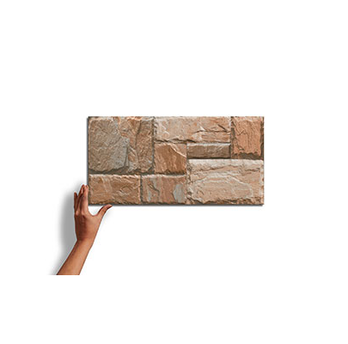

**COVRETTO**

A beautifully glazed porcelain collection from Italy creates a blend of marbles with a subtle antiqued look. Blending the veining of white Italian marbles (Carrara, Statuario, Gioia, and Venatino) in both White and Black creates a variety of sizes and patterns to create custom designs.

SPECIFICATIONS

**Country of Origin**

Italy

**Wear Rating**

Class 5 Suitable for all Residential and Commercial Application. Class 5 tiles are suitable for all applications including those with heavy traffic and constant use. (i.e., Shopping Malls, Hospitals), Class 3 Residential Applications. Suitable for all residential applications.

**Shade Variation**

V3 - Moderate Variation While the colors present on a single piece of tile will be indicative of the colors to be expected on the other tiles, the amount of colors on each piece will vary significantly.

**Frost Proof**

Yes

**Finish**

Glazed

**Material**

Porcelain

**Bullnose**

Yes

**OUTDOOR WALL TILES** TECHNICAL INFORMATION

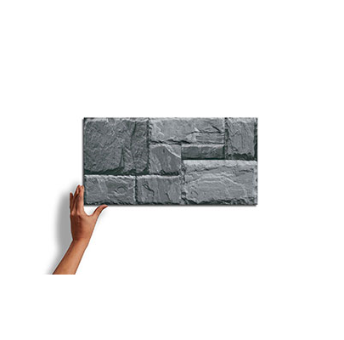

**BAROQUE FLORAL DARK**

A beautifully glazed porcelain collection from Italy creates a blend of marbles with a subtle antiqued look. Blending the veining of white Italian marbles (Carrara, Statuario, Gioia, and Venatino) in both White and Black creates a variety of sizes and patterns to create custom designs.

SPECIFICATIONS

**Country of Origin**

Italy

**Wear Rating**

Class 5 Suitable for all Residential and Commercial Application. Class 5 tiles are suitable for all applications including those with heavy traffic and constant use. (i.e., Shopping Malls, Hospitals), Class 3 Residential Applications. Suitable for all residential applications.

**Shade Variation**

V3 - Moderate Variation While the colors present on a single piece of tile will be indicative of the colors to be expected on the other tiles, the amount of colors on each piece will vary significantly.

**Frost Proof**

Yes

**Finish**

Glazed

**Material**

Porcelain

**Bullnose**

Yes

**OUTDOOR WALL TILES**  TECHNICAL INFORMATION

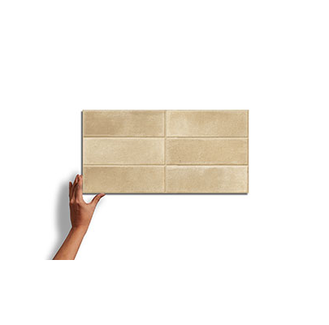

**NURIA GRIS**

A beautifully glazed porcelain collection from Italy creates a blend of marbles with a subtle antiqued look. Blending the veining of white Italian marbles (Carrara, Statuario, Gioia, and Venatino) in both White and Black creates a variety of sizes and patterns to create custom designs.

SPECIFICATIONS

**Country of Origin**

Italy

**Wear Rating**

Class 5 Suitable for all Residential and Commercial Application. Class 5 tiles are suitable for all applications including those with heavy traffic and constant use. (i.e., Shopping Malls, Hospitals), Class 3 Residential Applications. Suitable for all residential applications.

**Shade Variation**

V3 - Moderate Variation While the colors present on a single piece of tile will be indicative of the colors to be expected on the other tiles, the amount of colors on each piece will vary significantly.

**Frost Proof**

Yes

**Finish**

Glazed

**Material**

Porcelain

**Bullnose**

Yes

**OUTDOOR WALL TILES**  TECHNICAL INFORMATION

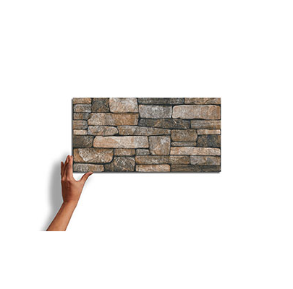

**BAYT NERO**

A beautifully glazed porcelain collection from Italy creates a blend of marbles with a subtle antiqued look. Blending the veining of white Italian marbles (Carrara, Statuario, Gioia, and Venatino) in both White and Black creates a variety of sizes and patterns to create custom designs.

SPECIFICATIONS

**Country of Origin**

Italy

**Wear Rating**

Class 5 Suitable for all Residential and Commercial Application. Class 5 tiles are suitable for all applications including those with heavy traffic and constant use. (i.e., Shopping Malls, Hospitals), Class 3 Residential Applications. Suitable for all residential applications.

**Shade Variation**

V3 - Moderate Variation While the colors present on a single piece of tile will be indicative of the colors to be expected on the other tiles, the amount of colors on each piece will vary significantly.

**Frost Proof**

Yes

**Finish**

Glazed

**Material**

Porcelain

**Bullnose**

Yes

**OUTDOOR WALL TILES**  TECHNICAL INFORMATION

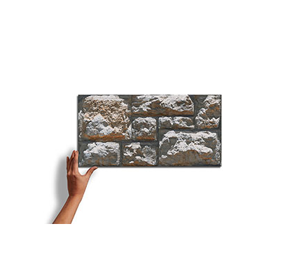

**SANDSTONE TUSK**

A beautifully glazed porcelain collection from Italy creates a blend of marbles with a subtle antiqued look. Blending the veining of white Italian marbles (Carrara, Statuario, Gioia, and Venatino) in both White and Black creates a variety of sizes and patterns to create custom designs.

SPECIFICATIONS

**Country of Origin**

Italy

**Wear Rating**

Class 5 Suitable for all Residential and Commercial Application. Class 5 tiles are suitable for all applications including those with heavy traffic and constant use. (i.e., Shopping Malls, Hospitals), Class 3 Residential Applications. Suitable for all residential applications.

**Shade Variation**

V3 - Moderate Variation While the colors present on a single piece of tile will be indicative of the colors to be expected on the other tiles, the amount of colors on each piece will vary significantly.

**Frost Proof**

Yes

**Finish**

Glazed

**Material**

Porcelain

**Bullnose**

Yes

**OUTDOOR WALL TILES**  TECHNICAL INFORMATION

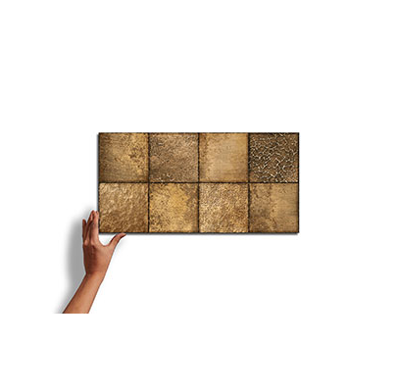

**ORFEO CHOCO**

A beautifully glazed porcelain collection from Italy creates a blend of marbles with a subtle antiqued look. Blending the veining of white Italian marbles (Carrara, Statuario, Gioia, and Venatino) in both White and Black creates a variety of sizes and patterns to create custom designs.

SPECIFICATIONS

**Country of Origin**

Italy

**Wear Rating**

Class 5 Suitable for all Residential and Commercial Application. Class 5 tiles are suitable for all applications including those with heavy traffic and constant use. (i.e., Shopping Malls, Hospitals), Class 3 Residential Applications. Suitable for all residential applications.

**Shade Variation**

V3 - Moderate Variation While the colors present on a single piece of tile will be indicative of the colors to be expected on the other tiles, the amount of colors on each piece will vary significantly.

**Frost Proof**

Yes

**Finish**

Glazed

**Material**

Porcelain

**Bullnose**

Yes

NOTES

Always inspect materials prior to installation.

Always mix 2-3 cartons at a time while installing to insure the best blend.

Per ANSI standard A108.02,4.3.82, tiles longer than 18” should not be staggered more than 1/3

the length of the tile.

All product images are representation only. Variation in color and shading is to be expected.

Final selection should be made from actual tile samples.